Title in Title Format

Presenting author,¹ contributing author²
¹Author affiliation and full address (Times, 10-point, centered, italicized)
²Author e-mail address: (Times, 10-point, centered, italicized)

Main body goes here. We recommend one page with text and one figure for the entire abstract. This is some dummy text. This is some dummy text. This is some dummy text. This is some dummy text. This is some dummy text. This is some dummy text. This is some dummy text. This is some dummy text. This is some dummy text. This is some dummy text. Example of reference [1].

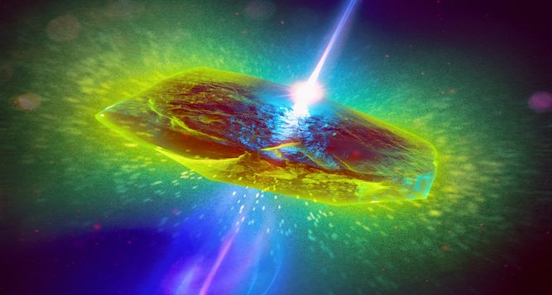
Figure 1. Use the format (a), (b), etc. for panel labels.
This is some dummy text. This is some dummy text. This is some dummy text. This is some dummy text. This is some dummy text. This is some dummy text. This is some dummy text. This is some dummy text. This is some dummy text. This is some dummy text.
References
[1] A. Penguin, A. Raccoon, and P. Bear, Phys. Rev. B 152, 184351, (2020).
Acknowledgments
Grants, etc.

