Manuscript Style for Submission to Workshop on Information Optics 2025 (Times, Title Case, bold, 14-point, centered)

Author name(s) [Times, 10-point, bold, centered]
Author affiliation and full address (Times, 10-point, centered, italicized)
Author e-mail address: (Times, 10-point, centered, italicized)

Abstract (35 words; Times, 11 pt.): Indented margins (1.25 cm), centered and justified. The template is designed for speakers of all invited talks and posters at Workshop on Information Optics 2025 to help format extended summaries to be published in the Proceedings of WIO 2025.
Summary (Times, 12-point, justified on both sides): The Workshop on Information Optics 2025 will be held in Castelldefels, Barcelona, Spain, during 30 June – 4 July 2025. It will be hosted by ICFO-The Institute of Photonic Sciences, who will also provide all local logistics.
The WIO 2025 submissions will be made available for all participants of the Workshop. Proceedings of WIO 2025 shall be published by the Springer Nature Applied Sciences [1,2].
Figures and tables should be centered (except for small figures, which may be placed side by side) and located inside paper margins. Text should not wrap around figures. Figure captions (9-point) should be centered below figures. Figures should appear as close as possible to where they are mentioned in the main text.
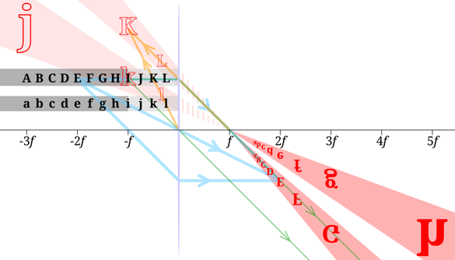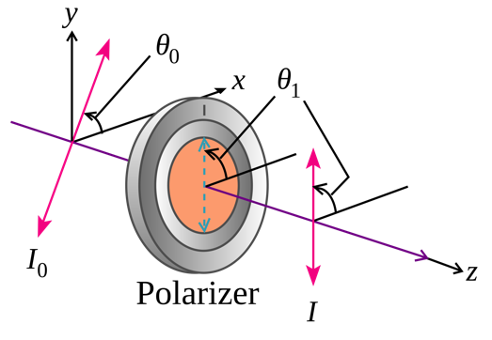
(b)
(a)

Fig. 1 (a) Images of black letters in a thin convex lens of focal length f are shown in red. Selected rays are shown for letters E, I and K in blue, green and orange, respectively. (b) A polarizer changing the orientation of linearly polarized light. In this picture, θ₁ – θ₀ = θ_{i}.
Tables should be centered and located inside paper margins. Table content should be in 10-point. Table captions (10-point) should be centered above tables. Tables should appear as close as possible to where they are mentioned in the main text.

Table 1. Example.

One | Two | Three
Eins | Zwei | Drei
Un | Deux | Trois
Jeden | Dvě | Tři
Equations should be centered, and equation numbers should appear to the right of the last line of the equation, in parentheses. For long equations, the equation number may appear on the next line.
(1)
The manuscript length should be 2 pages (invited talks) and 1-2 pages (posters) in A4 format, including all figures, tables, equations and references. References should include names of all authors, full name of journal or publications (9-point) and should be in the format shown below. Acknowledgments* should be listed after the references in the same font as the references in the list.
References
[1] A. Penguin, A. Raccoon, P. Bear, Physical Review B 152, 184351, (2020).
[2] …..
* Acknowledgement(s): authors (…) acknowledge support from NSF, (grant…), etc.

